Mosaic Change Request Process

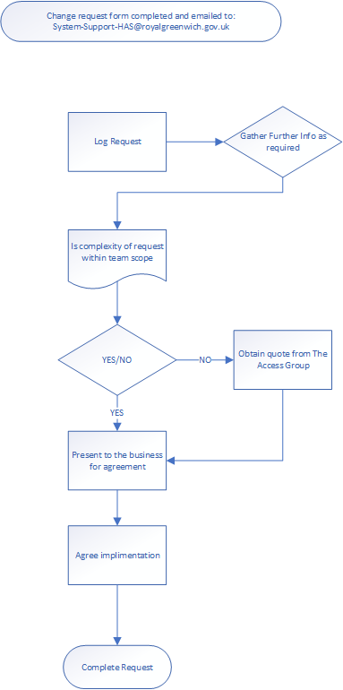 | All requests must have been authorised by a service manager, email the form to System-Support-HAS@royalgreenwich.gov.uk  Any complex changes that affect workflows across the directorate will require the business to sign off and agree on the costs in implementing these changes if the supplier needs to implement  All changes are fully tested before signing off, with user acceptance testing being completed.  Training and guidance will be produced with a monitoring review period agreed.  For further discussion on the process, please contact the team via System-Support-HAS
Mosaic – HAS CHANGE REQUEST FORM
146

PART A – To be completed by person requesting change

Once complete please email to system-support-HAS@royalgreenwich.gov.uk

Name of person making request
Date requested
Tel. Number
Department/Section
Line Manager

Part A to be completed by Requestor

Brief description of change requested (please provide as much information as possible – if appropriate, attach additional information).
Why do you need us to do this? What would be the impact of this not happening? (Business case that will assist with prioritising this piece of work).

PART B – To be complete by HAS Systems team

Who will be affected by this change?
Would this impact on the way we handle client information?
Will this affect Performance Reporting? (Will this change an existing report or need a new one?)
Will training or training guides be required? (Please state who would need training).

Date of Mosaic update meeting

Mosaic workers completing change request
Changes to system as part of change request

